**NITTE MEENAKSHI INSTITUTE OF TECHNOLOGY**

(AN AUTONOMOUS INSTITUTION, AFFILIATED TO VISVESVARAYA TECHNOLOGICAL UNIVERSITY, BELGAUM, APPROVED BY AICTE & GOVT.OF KARNATAKA



**PHASE-I REPORT**

### on

**APPLICATION OF DEEP LEARNING TO DEVELOP AUTONOMOUS VEHICLE**

*Submitted in partial fulfilment of the requirement for the award of Degree of*

*Bachelor of Engineering*

*in*

*Computer Science and Engineering*

*Submitted by:*

|  |  |
| --- | --- |
| MOHAMED SALMAN R MANOJ  RUDRESH M  MOHAMED JAFFAR NIYAZ | 1NT16CS055  1NT16CS084  1NT16CS091  1NT16CS157 |

Under the Guidance of,

#### Dr. Nalini N Professor, Dept. of CS&E, NMIT



Department of Computer Science and Engineering

# (Accredited by NBA Tier-1)

2019-20

**NITTE MEENAKSHI INSTITUTE OF TECHNOLOGY**

(AN AUTONOMOUS INSTITUTION, AFFILIATED TO VISVESVARAYA TECHNOLOGICAL UNIVERSITY, BELGAUM

, APPROVED BY AICTE & GOVT.OF KARNATAKA)

Department of Computer Science and Engineering

# (Accredited by NBA Tier-1)



## CERTIFICATE

This is to certify that the Phase 1 Report on **“Application of Deep Learning to Develop Autonomous Vehicle”** is an authentic work carried out by MOHAMED SALMAN (**1NT16CS055**), R MANOJ **(1NT16CS084),** RUDRESH M **(1NT16CS091)** and MOHAMED

JAFFAR NIYAZ **(1NT16CS157)** bonafide students of **Nitte Meenakshi Institute of Technology**, Bangalore in partial fulfilment for the award of the degree of ***Bachelor of Engineering*** in COMPUTER SCIENCE AND ENGINEERING of Visvesvaraya Technological University, Belagavi during the academic year ***2019-20.*** It is certified that all corrections and suggestions indicated during the internal assessment has been incorporated in the report.

|  |  |  |
| --- | --- | --- |
| **Internal Guide** | **Signature of the HOD** | **Signature of Principal** |
| Dr. Nalini N Professor, Dept. CSE, NMIT  Bangalore | Dr. Thippeswamy M. N. Professor, Head, Dept. CSE, NMIT Bangalore | Dr. H. C. Nagaraj Principal, NMIT,  Bangalore |
| **Signature of Examiners** |  |  |
| 1. |  |  |
| 2. |  |  |

# DECLARATION

We hereby declare that

1. The project work is our original work.
2. This Project work has not been submitted for the award of any degree or examination at any other University/College/Institute.
3. This Project does not contain any persons’ data, pictures graphs or other information, unless specifically acknowledged as being sourced from other persons.
4. This Project work does not contain other persons’ writing, unless specifically acknowledged as being sourced from other researchers. Where other written sources have been quoted, then:
   1. their words have been re-written but the general information attributed to them has been referenced.
   2. when their exact words have been used, their writing has been placed inside quotation marks and referenced.
   3. This Project work does not contain text, graphics or tables copied and pasted from the Internet, unless specifically acknowledged and the source being detailed in the thesis and in the References section.

|  |  |  |
| --- | --- | --- |
| **NAME** | **USN** | **Signature** |
| Mohamed Salman | 1NT16CS055 |  |
| R Manoj | 1NT16CS084 |  |
| Rudresh M | 1NT16CS091 |  |
| Mohamed Jaffar Niyaz | 1NT16CS157 |  |

### Date:

**ACKNOWLEDGEMENT**

The satisfaction and euphoria that accompany the successful completion of any task would be incomplete without the mention of the people who made it possible, whose constant guidance and encouragement crowned our efforts with success. I express my sincere gratitude to our Principal **Dr. H. C. Nagaraj**, Nitte Meenakshi Institute of Technology for providing facilities.

We wish to thank our HoD**, Dr. Thippeswamy M. N.** for the excellent environment created to further educational growth in our college. We also thank him for the invaluable guidance provided which has helped in the creation of a better project.

I hereby like to thank our **Dr. Nalini, Professor**, Department of Computer Science & Engineering on her periodic inspection, time to time evaluation of the project and help to bring the project to the present form.

We take this opportunity to thank our Departmental Project coordinators. We also thank all our friends, teaching and non-teaching staff at NMIT, Bangalore, for all the direct and indirect help provided in the completion of the project.

|  |  |  |
| --- | --- | --- |
| **NAME** | **USN** | **Signature** |
| Mohamed Salman | 1NT16CS055 |  |
| R Manoj | 1NT16CS084 |  |
| Rudresh M | 1NT16CS091 |  |
| Mohamed Jaffar Niyaz | 1NT16CS157 |  |

### Date:

**ABSTRACT**

Traveling by car is currently one of the most dangerous forms of transportation, with over a million deaths annually worldwide. As nearly all car crashes (particularly fatal ones) are caused by driver error, driverless cars would effectively eliminate nearly all hazards associated with driving as well as driver fatalities and injuries.

A self-driving car is a vehicle equipped with an autopilot system and is capable of driving from one point to another without aid from a human operator. Self-driving car technology was built initially using the robotics approach. But with the advancement in the field of computer vision and machine learning, we can use the deep learning approach. Major contests are conducted in the US for self-driving car technology to make it available to the world. Some of the well-known projects are EUREKA Prometheus Project (1987-1995) ARGO Project, Italy (2001) DARPA Grand Challenge (2004-2007) European Land-Robot Trial (2006-2008).

There are several challenges are needed to be met before implementing the self-driving car in the real world. It has to navigate through deserts, flat and mountainous terrains and handle obstacles like bridges, underpasses, debris, potholes, pedestrians and other vehicles.

**Keywords:** Deep Learning, Convolution Neural Network, Artificial Intelligence, Machine Learning, Artificial Neural Network

# CONTENTS

1. INTRODUCTION 1
   1. BACKGROUND 1
   2. BRIEF HISTORY OF TECHNOLOGY/CONCEPT 1
   3. APPLICATIONS 1
   4. RESEARCH MOTIVATION AND PROBLEM STATEMENT 2
      1. Research Motivation 2
      2. Statement of the Problem 2
   5. RESEARCH OBJECTIVES AND CONTRIBUTIONS 2
      1. PRIMARY OBJECTIVES 2
      2. MAIN CONTRIBUTIONS 3
   6. ORGANIZATION OF THE REPORT 3
   7. SUMMARY 4
2. LITERATURE SURVEY 5
   1. INTRODUCTION 5
   2. RELATED WORK 5
   3. STUDY OF TOOLS/TECHNOLOGY 12
   4. SUMMARY 14
3. SYSTEM REQUIREMENTS SPECIFICATION 15
   1. GENERAL DESCRIPTION 15
      1. Product Perspective 15
   2. SYSTEM REQUIREMENTS 15
      1. Hardware Requirements 15
      2. Software Requirements 15
   3. SUMMARY 16
4. DESIGN 17
   1. Architecture Design 17
   2. Dataflow Diagram 18
   3. Use Case Diagram 19
   4. Sequence Diagram 20
   5. Activity Diagram 21
5. CONCLUSION 22
6. REFERENCES 23

APPENDIX: PLAGIARISM REPORT 25

**LIST OF ACRONYMS**

1. NN - Neural Networks
2. ANN - Artificial Neural Networks
3. CNN - Convolutional Neural Networks
4. DL - Deep Learning
5. ML - Machine Learning
6. AI - Artificial Intelligence
7. GPU - Graphics Processor Unit
8. RADAR- Radio Detection and Ranging
9. LIDAR- Light Detection and Ranging
10. RAM - Random Access Memory

Application of Deep Learning to Develop

Autonomous Vehicle

# INTRODUCTION

## BACKGROUND

The evolution of AI and ML has served as an incentive in the field of technology. We can develop things which was, once upon a time, just an imagination. One such creation is the birth of Self- Driving Car. Days have come where one can do their work or even sleep in the car and without even touching the steering wheel, accelerator you will still be able to reach your target destination safely.

Driving is a skill that requires complex thinking and representation of the environment. Human errors can never be eliminated but accidents can definitely be stopped and this can happen from the current technologies.

## BRIEF HISTORY OF TECHNOLOGY/CONCEPT

Artificial Intelligence is the study of theory and development of computer systems able to perform tasks normally addition of human intelligence like the visual perception, speech recognition and more.

Reinforcement learning is considered as the subset of AI. Its an unsupervised learning for agent to learn and perform certain tasks in an environment. For the actions to be performed, various forms of Q tables are utilised.

The idea of self-driving vehicles was dated back from Futurama, from the New York’s Fair. General Motors (GM) was the first to implement with the autonomous vehicle back in the late 1930’s. Norman Bel Geddes created the first self-driving vehicle, which was an electric vehicle. In late 1970’s, the idea was improved upon this idea, cameras were used for processing of the images. Speed and calibration of the vehicle was improved.

## APPLICATIONS

Deep Learning has found many applications since the time it has come into existence. It has had and continues to have a wide array of industrial applications. One of the primary applications of deep learning is the self-driving car. It has also been useful in content moderation, fraud detection, etc. It is also used to find fake news articles and has been used as a tool to combat the spread of misinformation. Deep Learning is also extensively used in Natural Language Processing and its

Application of Deep Learning to Develop

Autonomous Vehicle techniques have improved the technology to a great extent. Extensive research in the field has led to the development of personalised assistants like Siri, Alexa, etc.

## RESEARCH MOTIVATION AND PROBLEM STATEMENT

## Research Motivation

The reasons behind choosing the aforementioned topic for this project are as follows:

* + - 1. Create an innovative solution to tackle the problems faced in modern transport.
      2. To survey and understand the state of autonomous cars.
      3. Understand the use of Artificial Neural Networks in the field of mobility and transport.

## Statement of the Problem

The following points illuminate the problems that this project tries to tackle.

* + - 1. Implement a system for a remote-controlled car that is automated and can make intuitive decisions for itself.
      2. Merge technologies such as Artificial Neural Networks, RADAR, LIDAR, etc. in the system.
         1. Play around with Deep Learning and figure out how we can get a better performance out of it.
      3. Test the system in real world scenarios.

## RESEARCH OBJECTIVES AND CONTRIBUTIONS

## PRIMARY OBJECTIVES

Following are the primary objectives of this project:

* + - 1. Incorporate a thoroughly autonomous driving vehicle.
      2. Work with Deep Learning and Artificial Neural Networks to train a self-driving car.
      3. Get ideal results in self-driving car performance.

## MAIN CONTRIBUTIONS

Following are the contributions of this project:

Application of Deep Learning to Develop

Autonomous Vehicle

* + - 1. Use of Multiple sensors like RADAR, LIDAR, Camera modules.
      2. Integrate Deep Learning and Artificial Neural Network with self-driving car.
      3. Visualization of rewards achieved by the self-driving car.

## ORGANIZATION OF THE REPORT

In the report the second chapter basically consists of literature survey where we have referred to various papers that are related to the project, these papers provide a solid foundation and a good starting point for the project.

The third chapter is the requirements section where we will be comprehensively covering the requirements of the project including hardware, software and other requirements.

The fourth chapter is the design section which details the architectural design of the entire system and various other diagrams.

The fifth chapter concludes our findings of the project and also the work done so far and future scope.

The sixth chapter lists all the references, papers, journals that have helped us in the project giving due credit to the author.

## SUMMARY

Application of Deep Learning to Develop

Autonomous Vehicle

The background of the project has been analysed thoroughly in order to understand the project better. The current requirements of the industry have also been taken into account to understand and fulfil them. A brief history of the technologies and concepts behind autonomously driven cars has been studied. The technologies, tools and the concepts to be used have been mentioned. The motivation of research behind the project and the problem statements have been identified. The contributions to the research of the technology have also been understood. The next imperative step is to survey the literature behind self-driven and autonomous cars.

Application of Deep Learning to Develop

Autonomous Vehicle

# LITERATURE SURVEY

## INTRODUCTION

There is no doubt that autonomously controlled cars are the future of mobility globally. Prominent car manufacturers like Mercedes-Benz, General Motors and Volvo, and technology providers like Google and Uber have led the way in being catalysts in this emerging technology. In order to understand the development of research in autonomous driving since its very inception, it is important to conduct a literature review to understand the different fields of application through which autonomous driving has evolved as well as to identify research gaps.

In the next few sections, the research involved, methodologies exhibited and findings of the literature review is presented.

## RELATED WORK

In this section, research articles and reports published by automobile manufacturers and technology companies are going to be discussed in brief. It will be followed by an examination of research papers published by individuals and organisations in journals like the IEEE.

#### NVIDIA DRIVE

NVIDIA DRIVE solutions span autonomous vehicle development from the cloud to the car, helping manufacturers collect data, train deep neural networks, and test, validate and operate self- driving cars.

Platforms have been designed by NVIDIA such as the NVIDIA DRIVE AGX Xavier system which incorporates processors for AI algorithms, sensor processing, mapping and driving.

NVIDIA also delivers a full software stack. NVIDIA DriveWorks is a software framework that enables sensor processing and calibration, deep neural networks, and data recording.

NVIDIA DRIVE AV provides necessary functions for full autonomous driving, including the ability to perceive, map and plan.

#### TESLA AUTOPILOT SYSTEM

Application of Deep Learning to Develop

Autonomous Vehicle

Autopilot is a feature introduced by Tesla in their Model S and Model X cars. Driver is still in control of the overall control of the car but Autopilot system provides a bunch of additional accident prevention measures. The system has the widely used Advanced Driver Assistant Systems (ADAS). Along with these other features it also provides automatic lane changing and other such features.

Autopilot has various features like Radar, 3D mapping, satellite imagery etc. Radars are present in the front bumper that help them to detect cars from a substantial distance.

Using high performance chipsets Tesla is able to map the vehicles captured in its camera to 3D space. Proximity sensors using ultrasonic sensors are also present. Satellite imagery is then used to detect oncoming traffic and warn the driver beforehand.

Although still in its early stages Tesla’s Autopilot system has a lot of robust features which could pave the way for future advancements in this field.

#### GOOGLE SELF-DRIVING CARS

Google driverless vehicle consists of sensors listed below:

* 1. A roof-top rotating LIDAR - uses array of 32 to 64 lasers to measure distances to objects to build a 3D image.
  2. Sensors as “eyes” - attached at the windshield, looking through for the near-by hazards.
  3. Bumper-mounted radar - keeping track of front and back vehicles.

Through all these sensors: lane detection was possible, obstacle detection was possible, adaptive cruise control for safe driving.

Sensors were also used to alert on weather conditions like to slow down in snowy or icy conditions. The car combines information gathered by Google Street View with AI software with the other sensors like LIDAR, weather sensor, and more, processes it with the Google made software and the end results hence help in having a fully autonomous system.

Application of Deep Learning to Develop

Autonomous Vehicle

#### MERCEDES-BENZ AUTONOMOUS DRIVING

Mercedes-Benz first came up with the DISTRONIC system in 1999. DISTRONIC is a driver assistance system which combines automatic speed regulation with proximity control in relation to a vehicle traveling in front

The S500 INTELLIGENT DRIVE prototype is equipped with the camera modules and radar sensors. The technology platform is able to know where it is, what it sees and how to react autonomously.

Based on gathered sensor data and determination of the vehicle's own position with reference to information from a digital map, the prototype then analyses the available free area for driving and plans its own route based on specific algorithms.

#### UBER/VOLVO AUTONOMOUS VEHICLE

Volvo use Nvidia’s Drive AGX Xavior computer to power their Level 2+ assisted driving vehicles. Nvidia system enables Volvo vehicles to monitor vehicle and personalization options.

Uber uses the current models of Volvo cars like XC90, which is considered as the safest car in the world.

The tasks used by Uber are:

* 1. Perception
  2. Localization
  3. Prediction
  4. Routing and Navigation
  5. Motion Planning
  6. Vehicle Control

Application of Deep Learning to Develop

Autonomous Vehicle

#### Real-Time Self-Driving Car Navigation Using Deep Neural Network - Truong-Dong Do, Minh-Thien Duong, Quoc-Vu Dang and My-Ha Le

In their paper, the authors describe the process of how they developed a self-driving car that is powered by raspberry pi. It is a miniscule of the entire model. They were able to achieve pretty high accuracy and have achieved this by using CNN. They have also noted that there is the problem of camera latency and this is where future work lies ahead.

#### Autonomous Cars: Past, Present and Future. A Review of the Developments in the Last Century, the Present Scenario and the Expected Future of Autonomous Vehicle Technology

**- Keshav Bimbraw**

In his paper, the author decode the past technologies that led to the increase in interest of autonomous vehicle technology and also reviews the current technologies that govern this field. He also observes certain trends in the future technologies. He outlines features such as ACC introduced by Volvo bring in a new dimension in the technology.

#### Misbehaviour Prediction for Autonomous Driving Systems - Andrea Stocco, Michael Weiss, Paulo Calzana, Marco Tonella

In their paper, the authors studied the problem of estimating the confidence of the deep neural network-based autonomous system in response to unexpected execution contexts and environments. The promising results in online misbehaviour detection, united with the availability of a labeled dataset of crashes and a simulation environment, can foster novel approaches for online prediction and self-healing of autonomous driving systems.

#### Autonomous Driving System on Deep Q Learning - Takafumi Okuma, Tad Gonsalves, Jaychand Upadhay

In their paper, the authors dealt with the simulation results of autonomous car learning to drive in a simplified environment containing lane markings and static objects. Learning was performed by

Application of Deep Learning to Develop

Autonomous Vehicle Deep Q Network; it computes Q values (rewards) corresponding to the actions available to an autonomous driving car.

#### Control Strategy of Autonomous Vehicles Based on Deep Reinforcement Learning - Wei Xia, Huiyun Li, Baopu Li

In this paper, the authors have proposed a new control strategy of self-driving vehicles using Deep Reinforcement Model, which learns with an experience of professional driver and a Q-learning algorithm.

#### Traffic Light Detection and Recognition for Self Driving Cars using DL - Ruturaj Kulkarni, Shruti Dhavalikar, Sonal Bangar

In this paper, the authors have specified applications of AI over several challenges like traffic lights, signs unclear lane markings, etc. It can be overcome by using the technologies of fields of Deep Learning, Computer Vision. They have proposed a Deep Neural Network based model for reliable detection and recognition of traffic lights using transfer learning. Also includes the use of fast Convolution NN (R-CNN) Inception V2 model in TensorFlow for transfer learning.

#### [Machine Learning for Cooperative Driving in a Multi-Lane Highway Environment](https://ieeexplore.ieee.org/document/8734192/) by Aashik Chandramohan, Mannes Poel, Bernd Maijerink, Geert Heijenk

In this paper, the authors have discussed how vehicular networking can be used for controlling an autonomous vehicle in a multi-lane highway environment. A driving algorithm is designed using Deep Q Learning. In order to train and test the driving algorithms, they have deployed a simulated traffic system, using SUMO (Simulation of Urban Mobility). The performance of the driving algorithm is tested for perfect knowledge regarding surrounding vehicles. They even tested the impact of limited communication range and random packet loss is investigated.

Application of Deep Learning to Develop

Autonomous Vehicle

#### Learning driving behaviour for autonomous vehicles using DL based methods - Zhenyu Wu, Chuanyi Li, Jiaying Chen, Hongbo Gao

In this paper a driving behaviour learning method based on DL is proposed. The driving behaviour is learned in different driving environments. The proposed method is then evaluated in the aspects of effectiveness and efficiency in the simulation experiments. Furthermore, decision making method making is also improved and designed.

#### MOD: Multi-Camera based Local Position Estimation for Moving Objects Detection – Jinwoo Kim, Yongbon Koo, SungHoon Kim

In this paper, the authors have specified about MOD (Moving Object Detection) technology combined with recognition, ID tracking, detection and classification by using sensor fusion to get information that local & global position estimation, pose estimation, velocity from around objects in real time over 15 fps. Darknet based DL method and modified detector is used to obtain a local position estimation. Their main purpose was to get moving object local position information from multi cameras fusion. So, they made the fusion server to synchronize and converse multi objects information from four cameras on our autonomous vehicle.

#### Lateral and Longitudinal Motion Control of Autonomous Vehicles using DL – Shobit Sharma, Girma Tewolde, Jaerock Kwon

In this paper, the authors have focused on how a DL technique is utilized for implementing Lateral and Longitudinal control of vehicles. The open racing car simulator (TORCS) is used for developing and testing the implementation. Two separate NN’s were trained that can predict the vehicle speed and steering based on the road trajectory.

Application of Deep Learning to Develop

Autonomous Vehicle

#### Self-Driving Car Steering Angle Prediction based on Deep NN An example of CarND Udacity Simulator – M.V. Smolakov, A.I. Frolov, V.N. Volkov, I.V. Stelmashchuk

In this paper, the possibility of using images from the emulator for training Deep NN’s for the prediction of steering angle is done. There exists an emulator generating the desired number of images of the vehicle movement easily. This approach allows car to move in automatic mode. They explored various architectures of CNN’s in order to obtain good results with a minimum number of parameters.

#### Reverse Parking Car – Like Mobile Robot with Deep Reinforcement Learning and Preview Control – Eduardo Bejar, Antonio Moran

In this paper a control technique for reverse parking car-like vehicles based on Deep Reinforcement Learning and preview control methods are used. The Deep Deterministic Policy Gradient (DDPG) algorithm is used for training a neuro-controller using a reward function defined in terms of desired final state of the system. A preview control approach is employed to leverage knowledge of a known a priori reference input to generate a predictive control signal coupled into the neuro-controller output. Simulation results were presented to validate the proposed method. The results also showed that incorporating a preview control signal improves the parking time.

#### Traffic Signs Identification by DL for Autonomous Driving – Wael Farag, Zakaria Saleh

In this paper, the authors have proposed and developed a comprehensive CNN classifier "WAF- LeNet" to be used in traffic signs recognition and identification. CNN architecture consists of a deep fifteen-layer network that has been selected after extensive trials and errors. The CNN was trained using Adam's optimization algorithm based on the scholastic Gradient Descent technique. The learning process was carried out using the "German Traffic Sign Dataset".

## STUDY OF TOOLS/TECHNOLOGY

Application of Deep Learning to Develop

Autonomous Vehicle

A brief overview of the technologies and tools used in the implementation of driverless autonomous cars will be discussed in this section.

#### Neural Networks

Neural networks are a set of algorithms, modelled loosely after the human brain, that is designed to recognize patterns. They can predict the output over a set of new input data through a kind of machine perception, labelling or clustering raw input as they learn to recognize and interpret patterns.

#### Convolutional Neural Networks

Convolutional Neural Networks as they are made up of neurons that have learnable weights and biases are similar to ordinary Neural Networks. Each neuron receives some inputs, performs a dot product and optionally follows it with a non-linearity activation function. The overall functionality of the network is like having an image on one end and class as an output on the other end. They still have a loss function like Logarithmic loss/ Softmax on the last (fully-connected) layer and all ideas developed for learning regular Neural Networks still apply. In simple words, images are sent to the input side and the output side to classify them into classes based on a probability score, whether the input image applied is a cat or a dog or a rat and so on.

#### RADAR and LIDAR

Radar and Lidar sensor fusion is essential to ensure that the cars behave as how they would under manual operating conditions. The car has to maintain a safe distance between itself and other objects in front and behind it. It is necessary to have a continuous, precise and accurate velocity and positional information about surrounding objects, which can be static or dynamic. Multiple sensors are installed in autonomous cars which have a field of vision such that the fusion of all of them can give the complete field of view.

#### Cameras

Cameras need to be installed in an autonomous car to provide it with vision. Autonomous vehicles rely on cameras placed on every side — front, rear, left and right — to stitch together a 360-degree view of their environment. Some have a wide field of view — as much as 120 degrees — and a

Application of Deep Learning to Develop

Autonomous Vehicle shorter range. Others focus on a narrower view to provide long-range visuals. The resultant visual output is fed to the convolutional neural network which helps the system determine its

surroundings.

#### Raspberry Pi

The Raspberry Pi is a very cheap computer that runs Linux, but it also provides a set of GPIO (general purpose input/output) pins that allow you to control electronic components for physical computing and explore the Internet of Things (IoT). The Raspberry Pi runs on the Raspbian Operating System. The Raspberry Pi can open opportunities for you to create your own home automation projects, which is popular among people in the open source community because it puts you in control, rather than using a proprietary closed system.

#### Keras

Keras is one of the leading high-level neural networks APIs. It is written in Python and supports multiple back-end neural network computation engines.

Neural layers, cost functions, optimizers, initialization schemes, activation functions, and regularization schemes are all standalone modules that you can combine to create new models. New modules are simple to add, as new classes and functions. Models are defined in Python code, not separate model configuration files.

#### Arduino

[Arduino](http://arduino.cc/) is an open-source platform used for building electronics projects. Arduino consists of both a physical programmable circuit board (often referred to as a [microcontroller](http://en.wikipedia.org/wiki/Microcontroller)) and a piece of [software,](http://arduino.cc/en/Main/Software) or IDE (Integrated Development Environment) that runs on your computer, used to write and upload computer code to the physical board.

#### Natural Language Processing

Natural language processing (NLP) is the ability of a computer program to understand human language as it is spoken. NLP is a component of artificial intelligence ([AI](https://searchenterpriseai.techtarget.com/definition/AI-Artificial-Intelligence)).

The development of NLP applications is challenging because computers traditionally require humans to "speak" to them in a programming language that is precise, unambiguous and highly structured, or through a limited number of clearly enunciated voice commands. Human speech,

Application of Deep Learning to Develop

Autonomous Vehicle however, is not always precise -- it is often ambiguous and the linguistic structure can depend on many complex variables, including slang, regional dialects and social context.

## SUMMARY

With sufficient knowledge of the work being carried out in this field and the study of the tools and technologies completed, the project can now shift its focus on developing a detailed requirements specification and the design flow.

Application of Deep Learning to Develop

Autonomous Vehicle

# SYSTEM REQUIREMENTS SPECIFICATION

## GENERAL DESCRIPTION

## Product Perspective

The following points below includes requirements for the model creation and evaluating performance:

* + - 1. Get sensor data of the surroundings.
      2. Feeding the data inputs to the Deep Learning algorithms.
      3. Obtaining the ideal end results from the model.
      4. Control of the car with respect to all of its components.
      5. Visualize the results in real time.

## SYSTEM REQUIREMENTS

This section will list the minimum computation power, libraries and tools needed for the project.

## Hardware Requirements

Following are the minimum requirements for the system to handle the processing:

* + - 1. Processors with 64bit address, minimum 2 cores and speed greater than 2 Ghz
      2. Minimum 8GB RAM for for good performance
      3. GPUs
      4. Robust Internet connection
      5. Raspberry Pi
      6. RADAR, LIDAR modules, camera modules

## Software Requirements

Following are the software libraries required for the project:

* + - 1. Python 3.7
      2. Tensorflow 2.0
      3. Keras
      4. Google Colab

Application of Deep Learning to Develop

Autonomous Vehicle

#### Functional Requirements & Non-functional Requirements

* + - * + **Functional Requirements:**

Functional Requirements are as follows:

1. Ability to modify vehicle behaviors to tackle various scenarios.
2. Suitable mechanism for misbehaviour prediction.
3. Robust error correction system.
4. Real time data collection.

#### Non-Functional Requirements:

The Non-Functional requirements are as follows:

1. Ability to collect the statistics of the various experiments conducted.
2. Ability to visualize the results.
3. Ability to compare the statistics of experiments run with changes in the hyper- parameters.

#### User Requirements

The user here is the developer himself and listed below are the points which a user would require:

1. Navigate the right path without breaking any traffic rules.
2. Provide the best Safety System.
3. Vehicle with the least error to prevent any sort of anomalies.
4. Algorithm must adopt to any extreme scenarios.

## SUMMARY

This chapter thus has shed light into the requirements the experimental setup has to fulfil to work on the problem domain. We are hopeful that the experimental setup will satisfy all the requirements mentioned in this chapter.

Application of Deep Learning to Develop

Autonomous Vehicle

# DESIGN

In this chapter, we will evaluate various subsystems and how each subsystem is built as well and how all these subsystems interact with each other to form a model.

## Architecture Design

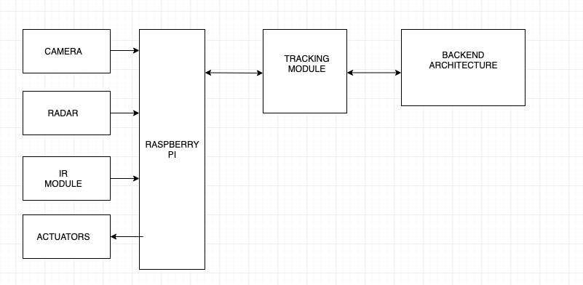

Figure 4.1: Architecture of Self Driving System.

Figure 4.1 indicates the complete architecture of the self-driving car. Raspberry Pi board is used as an interface between the software and hardware. The raspberry pi has modules like Camera, IR, Actuators, etc. These hardware modules are responsible for data collection based on which the neural networks work. The software module has two compartments interacting with each other Tracking module kind of forms the front end which shows the path of the car this interface is powered by the backend architecture that consists of the deep neural network.

## Dataflow Diagram

Application of Deep Learning to Develop

Autonomous Vehicle

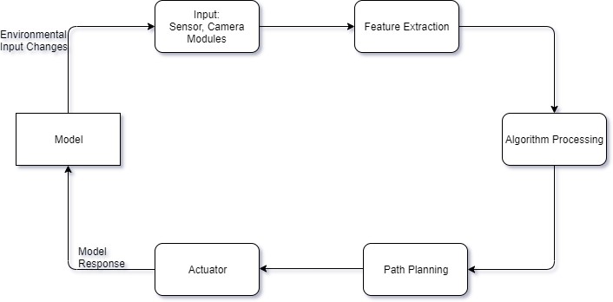

Figure 4.2: Dataflow Diagram of Model

Figure 4.2 indicates the Dataflow Model. It tells us about the data flow in a system and their interactions. Changes in its environment are sensed and a list of useful information are extracted which then further gets processed by the Deep Learning algorithms.

From the processed data, its right path will be judges and will proceed with respect to the end result.

## Use Case Diagram

Application of Deep Learning to Develop

Autonomous Vehicle

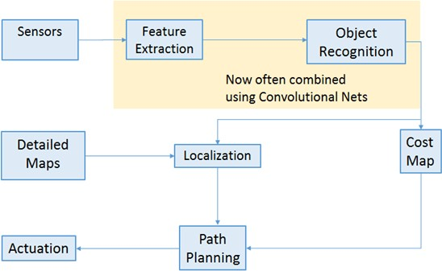

Figure 4.3: Usual approach for self-driving cars

Figure 4.3 indicates the expected behaviour of an autonomously controlled driving system is shown in the above diagram. The sensors detect the changes in the surroundings and send the data to a Convolutional Neural Network (CNN). This CNN extracts the features and the Cost Map of the same is evaluated. Using localization and path planning algorithms, the necessary controls can be passed onto the actuators to control the car.

## Sequence Diagram

Application of Deep Learning to Develop

Autonomous Vehicle

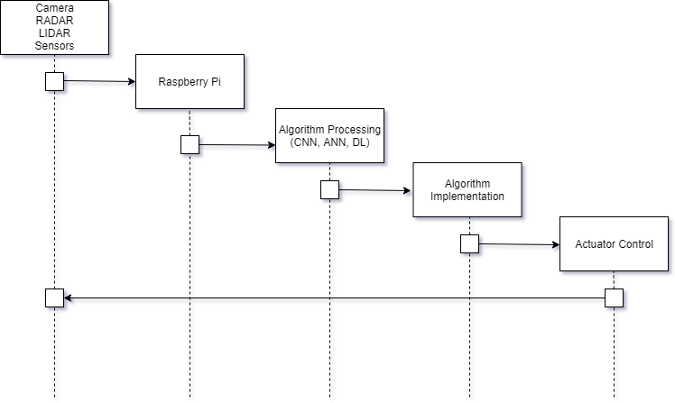

Figure 4.4: Sequential Flow of model

From the Sensors, RADAR, LIDAR and Camera modules, the environmental information will be collected. This information is going to be bundled together and passed to the Raspberry Pi. The Pi will consist of all the classifications needed to predict the further actions to be taken. Algorithms like Convolution Neural Network, Artificial Neural Network, Deep Learning and many more algorithms will be used which will predict the further actions to be performed and will be implemented by the Actuators.

## Activity Diagram

Application of Deep Learning to Develop

Autonomous Vehicle

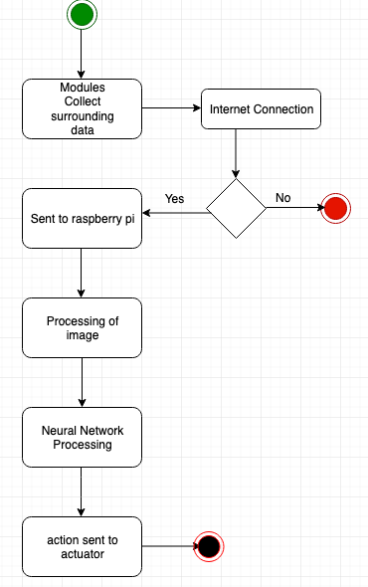

Figure 4.5: Step-by-Step Activity Functionality

Figure 4.5 indicates the activity flow of the entire system. Camera and various other modules help in sensing the surroundings and based on the connectivity these data are sent to raspberry pi. Here processing of image takes place results of which are passed on to the neural network which then governs the movements of actuators.

Application of Deep Learning to Develop

Autonomous Vehicle

# CONCLUSION

This project will aim to come up with the following results which are going to be important from an algorithmic point of view.

1. Implement a system for a remote-controlled car that is automated and can make intuitive decisions for itself.
2. Illustrate the use of Deep Learning concepts in the field of automation.

An appropriate study of the literature survey has been conducted. Hardware requirements, software requirements, functional and non-functional requirements, and user requirements have been clearly identified for the project. Systematic designs of an ideal self-driving car have been contemplated upon and will be implemented in the project.

We believe there is a lot to be explored and implemented in the field of deep learning in the application of self-driving cars. Smoothening the jerkiness of the self-driving car, identification of lanes and traffic signs, and object detection is a huge challenge. Extensive work and research has to be conducted to overcome these challenges.

Application of Deep Learning to Develop

Autonomous Vehicle

# 6. REFERENCES

1. NVIDIA Corporation, “NVIDIA DRIVE: Scalable AI Platform For Autonomous Driving”, [Online] Available: [https://www.nvidia.com/en-us/self-driving-cars/drive-platform](https://www.nvidia.com/en-us/self-driving-cars/drive-platform/) [Accessed: September 2019]
2. Tesla Inc., “Autopilot: Future of Driving”, [Online] Available: <https://www.tesla.com/autopilot> [Accessed: October 2019]
3. Google Inc., “Google Driverless Car”, [Online] Available: [https://www.academia.edu/14740725/A_SEMINAR_REPORT_ON_GOOGLE_DRIVERLESS_ CAR_](https://www.academia.edu/14740725/A_SEMINAR_REPORT_ON_GOOGLE_DRIVERLESS_CAR_) [Accessed: October 2019]
4. Mercedes-Benz, “Mercedes-Benz Innovation: Autonomous Driving”, [Online] Available: <https://www.mercedes-benz.com/en/next/automation/>[Accessed: October 2019]
5. Uber/Volvo, “Uber’s Self-Driving Technology”, [Online] Available: <https://uber.app.box.com/v/UberATGSafetyReport>[Accessed: October 2019]
6. T. Do, M. Duong, Q. Dang and M. Le, "Real-Time Self-Driving Car Navigation Using Deep Neural Network," *2018 4th International Conference on Green Technology and Sustainable Development (GTSD)*, Ho Chi Minh City, 2018, pp. 7-12.
7. K. Bimbraw, "Autonomous cars: Past, present and future a review of the developments in the last century, the present scenario and the expected future of autonomous vehicle technology," *2015 12th International Conference on Informatics in Control, Automation and Robotics (ICINCO)*, Colmar, 2015, pp. 191-198.
8. A. Stocco, M. Weiss, M. Calzana and P. Tonella, “Misbehaviour Prediction for Autonomous Driving Systems”, arXiv: 1910.04443, October 2019.
9. T. Okuyama, T. Gonsalves and J. Upadhay, "Autonomous Driving System based on Deep Q Learning," *2018 International Conference on Intelligent Autonomous Systems (ICoIAS)*, Singapore, 2018, pp. 201-205.
10. W. Xia, H. Li and B. Li, "A Control Strategy of Autonomous Vehicles Based on Deep Reinforcement Learning," *2016 9th International Symposium on Computational Intelligence and Design (ISCID)*, Hangzhou, 2016, pp. 198-201.

Application of Deep Learning to Develop

Autonomous Vehicle

1. R. Kulkarni, S. Dhavalikar and S. Bangar, "Traffic Light Detection and Recognition for Self Driving Cars Using Deep Learning," *2018 Fourth International Conference on Computing Communication Control and Automation (ICCUBEA)*, Pune, India, 2018, pp. 1-4.
2. A. Chandramohan, M. Poel, B. Meijerink and G. Heijenk, "Machine Learning for Cooperative Driving in a Multi-Lane Highway Environment," *2019 Wireless Days (WD)*, Manchester, United Kingdom, 2019, pp. 1-4.
3. Z. Wu, C. Li, J. Chen and H. Gao, "Learning driving behavior for autonomous vehicles using deep learning based methods*," *2019 IEEE 4th International Conference on Advanced Robotics and Mechatronics (ICARM)*, Toyonaka, Japan, 2019, pp. 905-910.
4. J. Kim, Y. Koo and S. Kim, "MOD: Multi-camera Based Local Position Estimation for Moving Objects Detection," *2018 IEEE International Conference on Big Data and Smart Computing (BigComp)*, Shanghai, 2018, pp. 642-643.
5. S. Sharma, G. Tewolde and J. Kwon, "Lateral and Longitudinal Motion Control of Autonomous Vehicles using Deep Learning," *2019 IEEE International Conference on Electro Information Technology (EIT)*, Brookings, SD, USA, 2019, pp. 1-5.
6. M. V. Smolyakov, A. I. Frolov, V. N. Volkov and I. V. Stelmashchuk, "Self-Driving Car Steering Angle Prediction Based On Deep Neural Network An Example Of CarND Udacity Simulator," *2018 IEEE 12th International Conference on Application of Information and Communication Technologies (AICT)*, Almaty, Kazakhstan, 2018, pp. 1-5.
7. E. Bejar and A. Morán, "Reverse Parking a Car-Like Mobile Robot with Deep Reinforcement Learning and Preview Control," *2019 IEEE 9th Annual Computing and Communication Workshop and Conference (CCWC)*, Las Vegas, NV, USA, 2019, pp. 0377-0383.
8. W. Farag and Z. Saleh, "Traffic signs identification by deep learning for autonomous driving,"

*Smart Cities Symposium 2018*, Bahrain, 2018, pp. 1-6.

Application of Deep Learning to Develop

Autonomous Vehicle

# APPENDIX: PLAGIARISM REPORT